**Working with JavaScript Libraries**

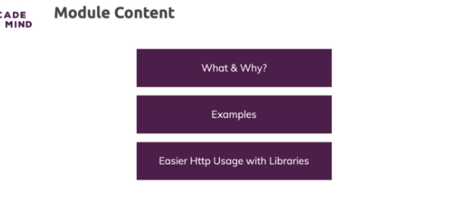

**What & Why**

* Third-party libraries are essentially packages of code, typically packages of functions written in Javascript which have all that logic in them
* so that you can just reach out to these predefined, prewritten functions and functionalities and use them in your project
* So third-party libraries are really all about adding utility functions of different complexities, can be very simple, very trivial utility functions or more complex functionalities which you want to add

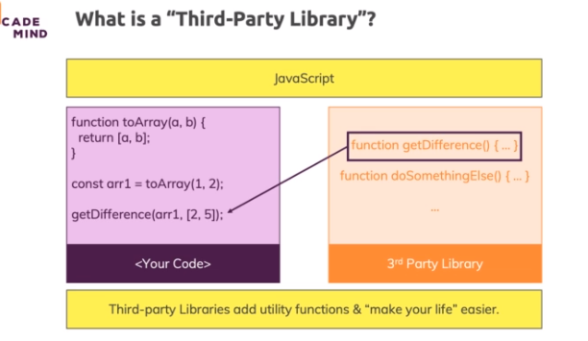

**Adding Libraries (Example: lodash)**

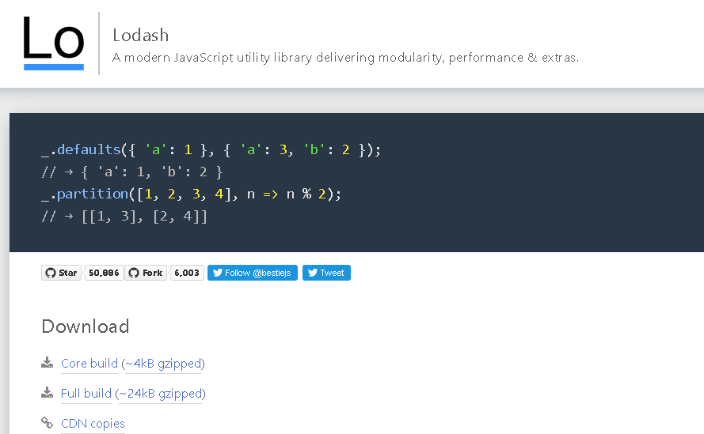

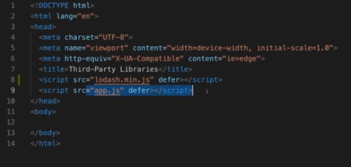

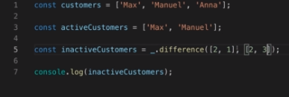

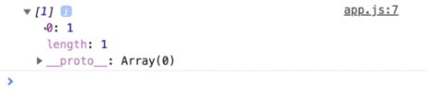

**Example: jQuery**

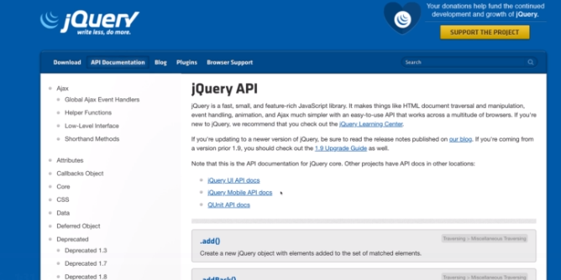

* JQuery is not about giving you utility functions like getting the difference of two arrays but it gives you a lot of functions that help you work with the DOM